Chris Cordaro
Homework 1

a)
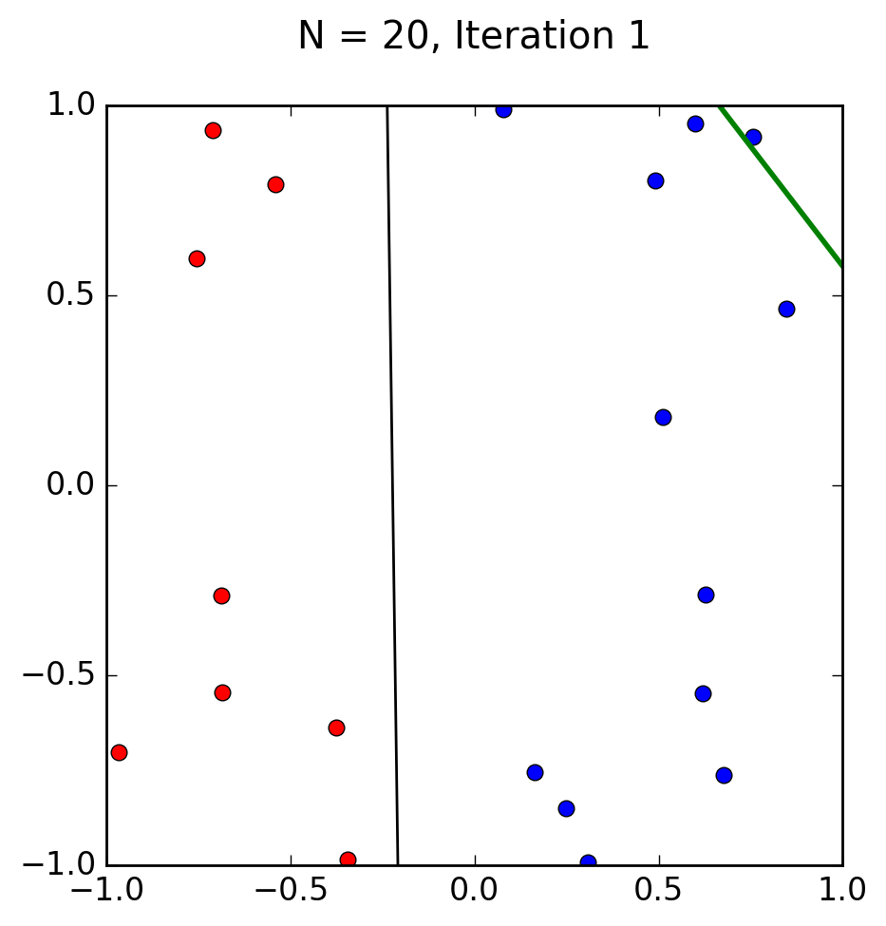

b) The perceptron took 4 iterations to find the target function. F is relatively close to G
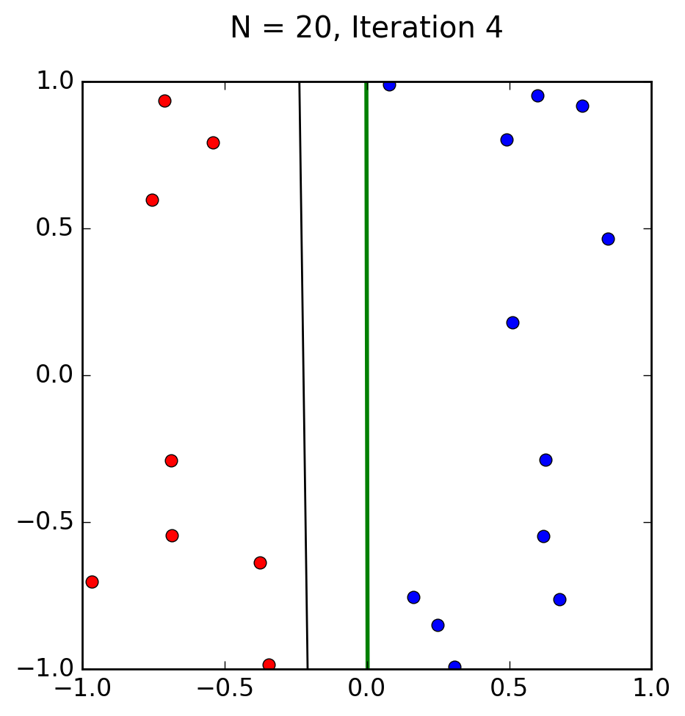

c) This perceptron took a total of 6 iterations.
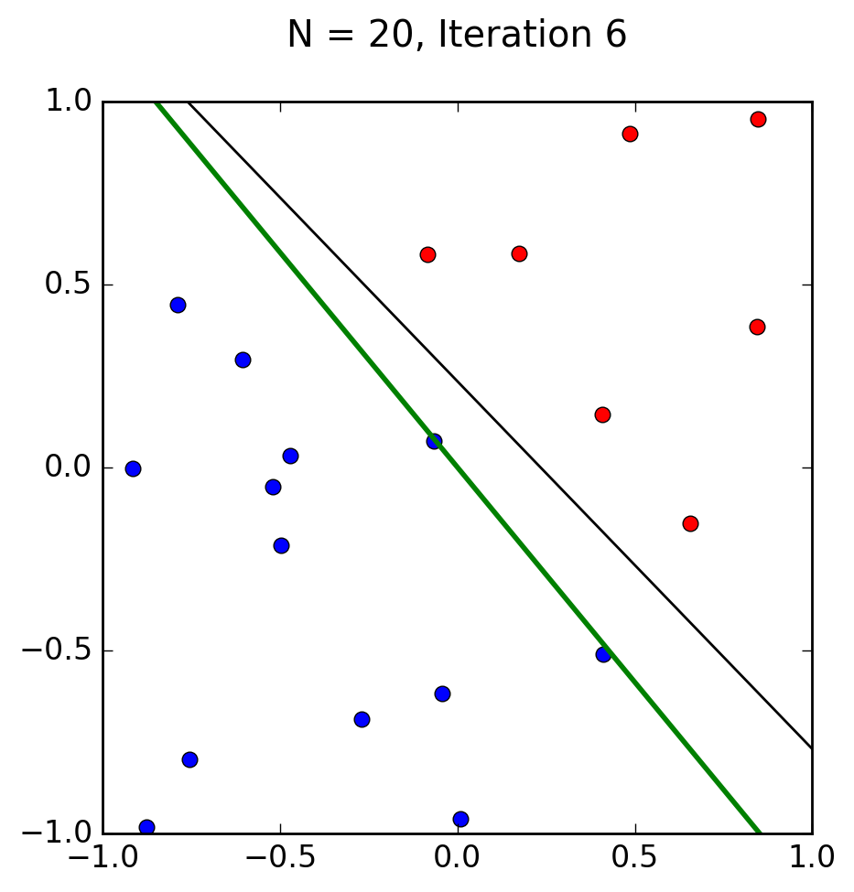

d) 100 Data-points took 137 iterations. F is again relatively close to G. 20 data points took an average of 5 iterations to complete. It would be expected that 100 data points would take 20 iterations, however it took 137.
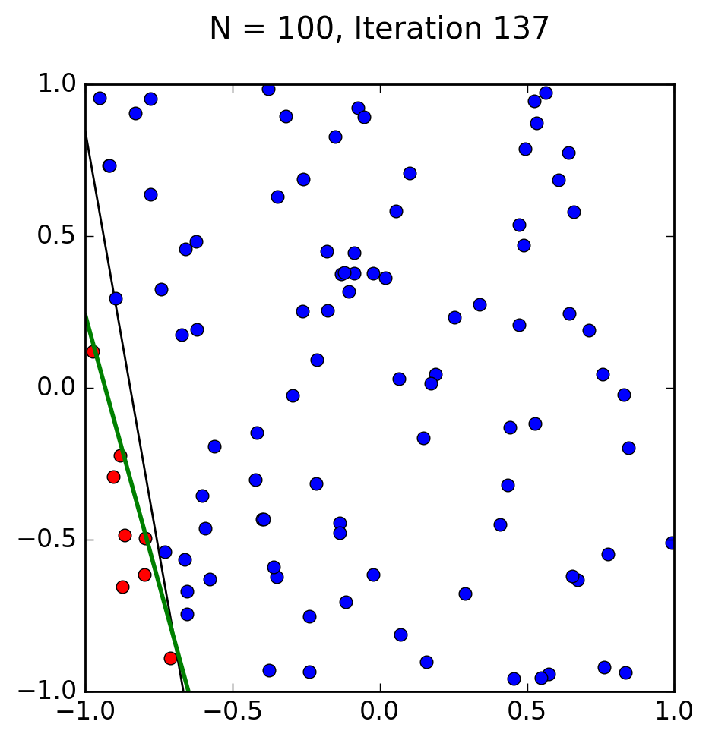

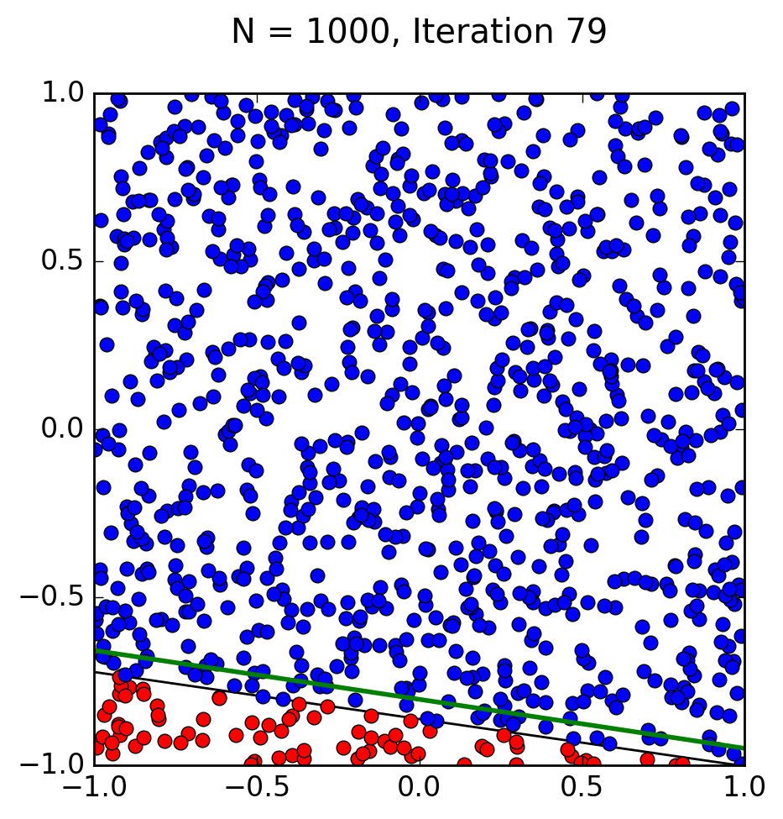
e)With 1000 data points, my computer stopped at iteration 79 because it “ran out of memory”. I expect that if I were to run this on a server, 1000 data points would take the perceptron over 1500 iterations. Each iteration took approximately 3 seconds, but I’m not sure if that is a result of the amount of points python had to plot, or the logic behind moving the hypothesis line.

f) With a 10 dimension data set of 1000 points, the perceptron too 5228 updates to converge.

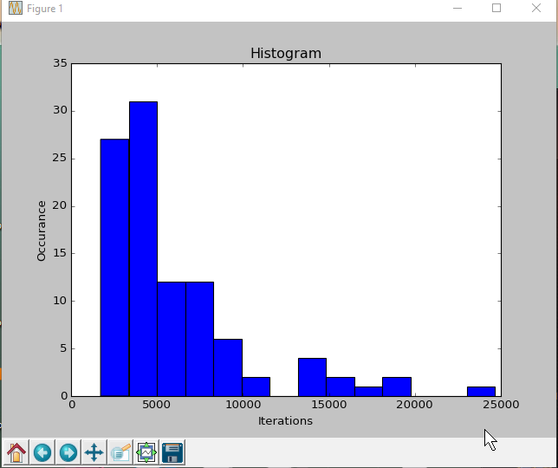
g) Randomly generated instead of linearly separable data set.

h) Overall the perceptron seems to be a decent algorithm to find a hypothesis for a given input. However, with a O(n)^2 run time it is not advised to use with larger data sets. Another issue with the perceptron is that the data has to be linearly separated; as demonstrated in class, a data set with 4 points being in each corner stumps the perceptron into an infinite loop where it will never find a solution. When the perceptron does find an answer, it may not be the best hypothesis, just a single hypothesis that fits the data, which in certain situations where accuracy is paramount, could cause many issues. Furthermore the perceptron, without modification, will fail to find a hypothesis that fits a curve rather than a straight line.

